Hong Kong Institute of Vocational Education (Tsing Yi)

Department of Information and Communications Technology
ITP4507 – Contemporary Topics in Software Engineering

Laboratory Exercise 1 – Basic Techniques for Embracing Changes in Object Oriented Software Design

Answer for diagrams and discussion:

Q3 Part A i)

Codes which are required changes are highlighted in red.

public class Main {

public static void main(String[] args) {
Cal cal = new Cal();
cal.compute();
}
}

public class Cal {

public void compute() {
int x = 2, y = 3;
String s = "hello";

System.out.println("Cal: compute()");
int n = method1(x, y);
int m = method2(s);
System.out.println("method1(" + x + "," + y + ")" + "=" + n);
System.out.println("method2(" + s + ")" + "=" + m);
}

int method1(int x, int y) {
System.out.println("Cal: method1(" + x + "," + y + ")");
return x + method3(y);
}

int method3(int y) {
System.out.println("Cal: method3(" + y + ")");
return 2*y;
}

int method2(String s) {
System.out.println("Cal: method2(" + s + ")");
return s.length()-2;
}

}

Q3 Part A iv)

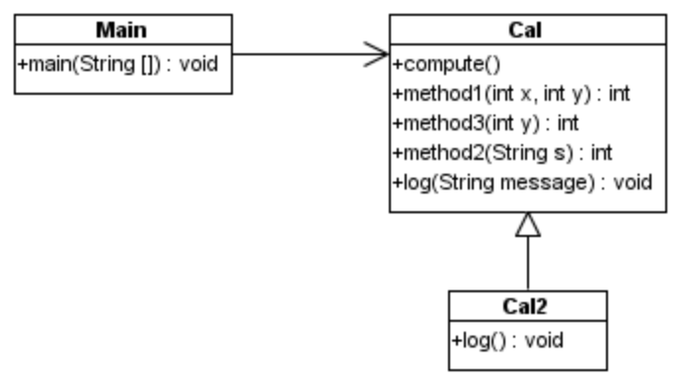

Q3 Part B v)

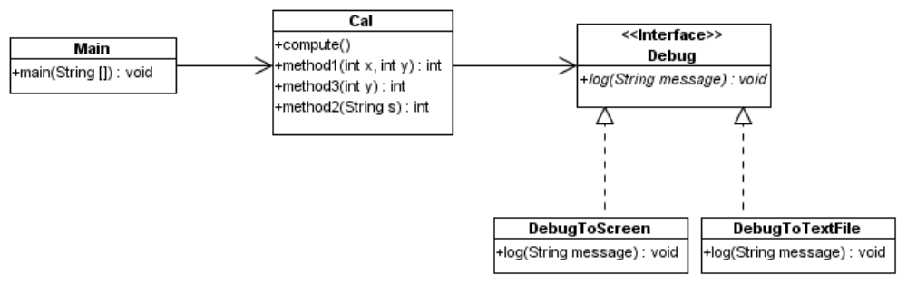

Q3 Part C

Advantages of using separate class:

- ease to add new implementation of the required methods
- componentize functions into different classes, and a program can be changed by composing different classes (components) together to achieve the desired functions or requirements.

